Chicago Taxi Trips Study

Joshua Balson <[jbalson@mail.smu.edu](mailto:jbalson@mail.smu.edu)>

Hieu Nguyen <[hdnguyen@mail.smu.edu](mailto:hdnguyen@mail.smu.edu)>

Cam Lu <[ctlu@mail.smu.edu](mailto:ctlu@mail.smu.edu)>

Master of Science Data Science, Southern Methodist University

Course: MSDS7330, Instructor: Jongwook Woo

**Abstract:** The purpose of this research is to analyze taxi rides taken in Chicago from 2013 through 2017 to determine whether the city of Chicago is “centralized”. We will answer this question by analyzing the ratio of taxi rides where the destination was either to or from downtown compared to all taxi rides taken from 2013 to 2017.

A secondary area of focus will be to analyze whether the metro system in Chicago complements or detracts from the business of taxi drivers. In other words, “are taxis competing with the metro system by covering similar routes or supplementing metro routes by getting people to and from train stations?”.

**1. Related Work**

A data set was published by Kaggle, but contains only taxi trips taken in 2016. Kaggle’s data set replaces latitude and longitude with ‘community areas’. This makes it more difficult to perform analysis around pick-up and drop-off locations. Kaggle consumers have used this data set to analyze many things outside the scope of this analysis – such as rush hour heat maps, fare versus ride time, etc. However, there is not a lot (if anything) posted that deals directly with the purpose of our research. This may be due to the way that Kaggle modified the “raw” data set that is provided by the City of Chicago, which may have discouraged data scientists from engaging in the type of analysis we wish to perform.

Due to the issues encountered with Kaggle’s data set, we chose to instead focus on the more robust data set (which ranges from 2013 through 2017 and includes lat/lon) provided by the City of Chicago. This data set was last updated in August of 2017. The City of Chicago also maintains a dashboard of the data. This dashboard contains many views which show time duration histograms, drop-off and pick-up location volumes, and many more. It should be noted that the City of Chicago maintains many other data sets that would be of interest to researchers and analysts[1].

2. Introduction

At the time of this paper, the full City of Chicago data set contains 113 million rows of data and 23 colums of information, where each row represents one unique taxi trip. This makes it very difficult to download the data set, much less analyze it! MongoDB was used to upload the data and a mixture of SQL and Tableau was used for the analysis.

Before we get started on the analysis, it would be good to familiarize ourselves with the City of Chicago in general. It will also be necessary to know some basic facts about Chicago’s rapid transit system.

The city of Chicago is the third largest city in the U.S. with approximately 2.7 million residents and a metro population of over 9.5 million. Chicago’s downtown area is known as “the loop”[2]. This refers to the area encircled by the elevated (“L”) rapid transit tracks. The “L” has eight different routes, and average weekday ridership was over 750,000 in 2015[3]. Map 1 below shows the city of Chicago and its downtown “center”.

**Map 1:**

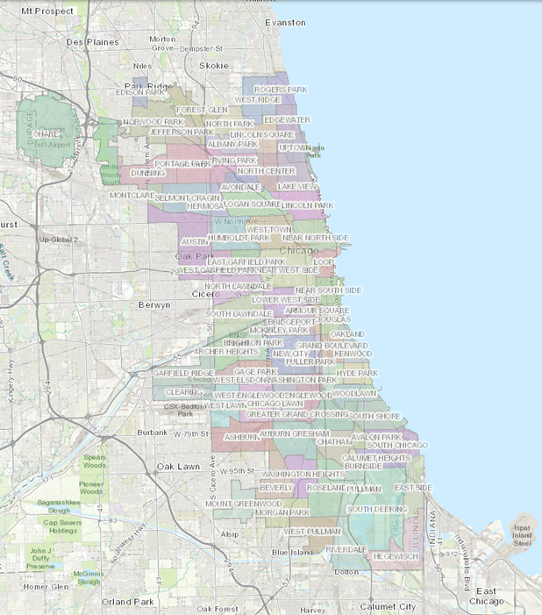

Chicago Downtown Center

Map 2 shows the city of Chicago’s “L” lines. The lines that form the loop in the map encircle Chicago’s downtown center.

**Map 2:**

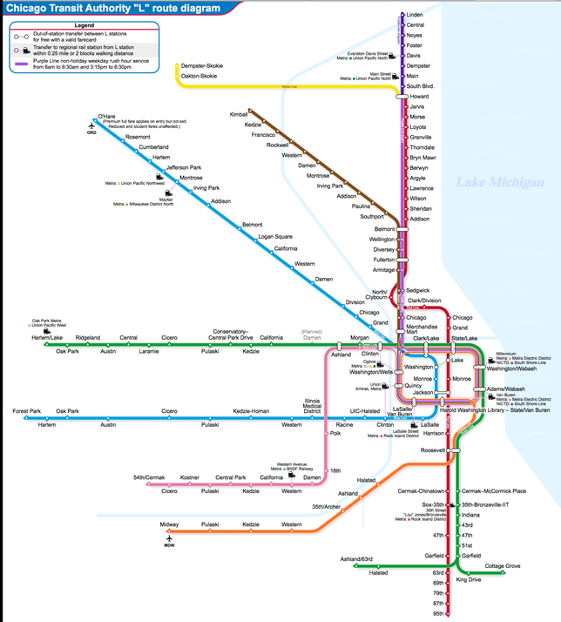

**3. Analysis**

Figure 1-1 to the right displays the Chicago map with Chicago “L” railway line stations, trip origin, and trip destination. The data shows more concentrated passenger pick-ups and drop-offs along the “L” lines on the north-west (area 1 and area 2) of Chicago centroid location. Further away from Chicago centroid, like areas 1 and 2, there are a lot less taxi passengers except O’Hare and Midway airports.

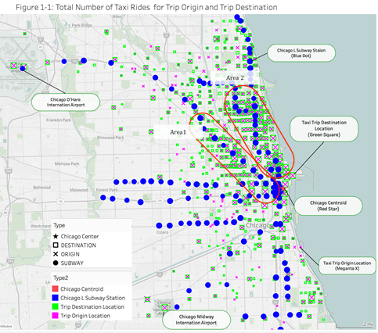

Figure 1-2 on the next page displays the zoom area for Chicago’s north-east region. Most locations for taxi pick-ups and drop-offs are a good distance away from the “L” line stations. The locations of taxi pick-ups and drop-offs are evenly distributed along the downtown area, especially the areas not covered by an “L” station. This is a strong indication that taxis are not covering similar routes as the “L” stations, but are supplementing public transit by getting people to and from downtown

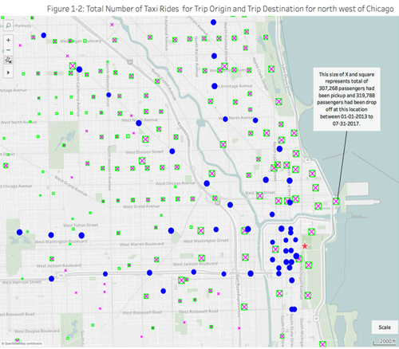

Figure 2-1 displays the average distance traveled at each location for each passenger origin and destination. A bigger x or circle represents a longer distance traveled. The data shows short trip around 2 miles average distance in the region of Chicago downtown. This is an indication that passengers use the taxi for short trips for the areas in downtown that are not covered by the subway. Therefore, there is evidence to suggest that taxis are not covering similar routes of the subway, but are supplementing public transit by getting people to and from downtown.

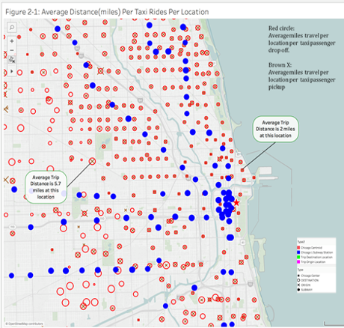

1. <https://data.cityofchicago.org>
2. ** https://www.choosechicago.com/plan-your-trip/chicago-fun-facts/
3. http://www.cnn.com/2013/11/01/us/chicago-transit-authority-fast-facts/index.html